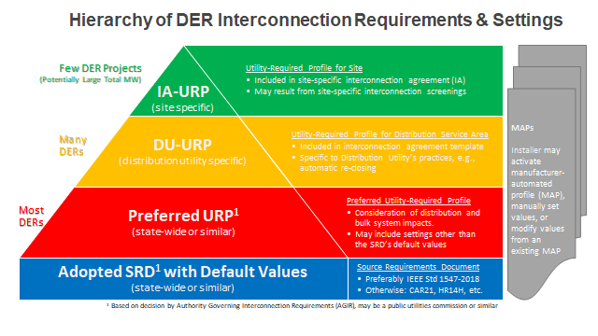
Minimum State-wide Default Standard

